

**REMOTE RECRUITMENT**

**PWP Selection Candidate Information Pack October 2025**

**Interview process and guidance**

**Contents**

* Email detailing time, date, link to online interview room- attached
* Outline of interview process
* Appendix 1 Role Play guidelines
* Appendix 2– How to guide for ‘Blackboard Collaborate’

**Remote Processes**

* The NHS Talking Therapies service provider will send the link and details of the remote interview in the candidate invitation to interview email.
* The service provider may have asked the University to deliver the interviews via the University’s online teaching platform – Blackboard Collaborate. If so, please see below.
* A step-by-step guide to logging into Blackboard Collaborate has been included below.
* The panel will normally be comprised of 2 university tutors. If different from this the reason will be explained on the day.
* The recruitment process will be carried out remotely, but candidates need to consider that, if teaching goes back to face to face, they will be required to attend the University in person for this.

**Technology**

Blackboard Collaborate is an online learning environment used by the university for teaching, simulated clinical observations, interviews and tutorials. Access is enabled via a link sent from the NHS TT Admin team.

**Candidates will need to access via Google Chrome or Firefox to allow full video and audio functionality. You will require a strong wi-fi signal and fast internet connection. If the internet is not fast enough, the microphone and camera will not function. If your wi-fi is not fast enough, please connect to your router directly with an Ethernet cable.**

All candidates can access the test room prior to their interview to test their equipment. The link to this test room is here:

<https://eu.bbcollab.com/guest/074a6ef362e14c23893990929335bae2>

**Outline of Interview Process**

The interview will last approximately 45 minutes.

The interview will commence with a 10-minute role play with a common mental health problem. Guidance on the role play is included in this interview pack, see appendix 1.

Following your role play you will be asked questions by the panel.

Finally, you will have the opportunity to ask the panel any questions regarding the training course.

**It is very important that you do not share the contents of this pack or discuss the interview with any fellow applicants as this may lead to an unfair advantage.**

The outcomes of the university interviews will be communicated to the services who will then consider all feedback and make a final decision on selection. Services will communicate the outcome of the selection process to the successful candidates.

As a number of NHS TT services will be advertising and recruiting trainee PWPs at the same time, it is likely that candidates will apply for training positions with more than one NHT Talking Therapies service. In the eventuality that candidates are put forward for a university interview by more than one service, we ask that candidates inform both the service and University of this. Candidates will only be offered one university interview, regardless of how many successful service interviews they undertake. The outcome of the university interview will be shared with the relevant services. Additionally, the university will inform services when candidates have been offered positions by one or more services.

**Previous enrolment on a funded PWP training course**

Repetition of training is not supported if the candidate has completed a funded training programme and failed.

Candidates who have previously withdrawn from a funded course will be considered only upon receipt of an academic reference from the original University. This reference must indicate that the individual’s withdrawal was due to clear extenuating circumstances which would suggest that a repetition of training would be good use of public money.

Candidates who have previously withdrawn from a funded PWP course should bring the following information to the interview:

* Name of the institution attended
* Name of the course
* Departmental name/ contact number and email for the course

**Current enrolment on a HEI training course**

The University of Sheffield is unable to accept any candidates who are currently enrolled on any training course at any other HEI institution.

**Right to Work in the UK**

All candidates who hold a visa should ensure that their visa permits the right to work and study in the UK. As the course incorporates both work and study, it is the University’s understanding that both the Student visa and the Graduate Route visa prevent candidates from completing both elements of the course without breaching their visa conditions:

* The Student visa is bound by Student visa work conditions which would not allow the candidate to work in the full time permanent position required by the service.
* The Graduate Route visa does not permit the level of study associated with the course.

There may also be restrictions on other visa types. It is the responsibility of the candidate to ensure their visa permits both work and study to the degree required by the course. Any candidate who is successful in obtaining a place on the course, but does not hold an appropriate visa, will not be permitted to register on the course.

If a candidate is unsure as to whether their visa permits both work and study, they should obtain independent advice from an authorised immigration adviser or legal professional.

**Student Support Services**

If any successful candidate has a learning need, or disability which may impact on learning, we advise contacting the university disability and dyslexia support service (DDSS) as soon as possible before the course starts. This will enable learning support to be put in place prior to commencement of training.

For further information on who should seek support from the DDSS and how to access them please follow the link below:

https://www.sheffield.ac.uk/new-students/disability

Appendix 1: Role-play guidance for candidate

You will be asked to interview a patient who has been referred to you by his / her GP. The interview will be conducted for a period of 10 minutes. You should aim to include a beginning, middle and end within the 10 minutes role play. We do not expect you to showcase the first 10 minutes of 30-45 minute session, nor do we expect you to condense a 30-45 min session into 10 minutes. It is your first meeting and the main purpose of the role play is to engage with the person and gather information about their problems and whether you may be able to help them as a PWP.

You do **not** need to explain about confidentiality or do a full assessment of risk.

The main aim of the role is to engage with the person and get a sense of what their difficulties are. The person playing the role of the patient will not be difficult.

You only have 10 minutes and ideally you need to end the interview within the time period. You will receive a one-minute warning near the end.

You may use pen and paper if required or if you want to. Any notes shared with the patient should be made with a bold, black felt tip pen on blank paper to aid visibility across the video. This is not a requirement.

Appendix 2

**Blackboard Collaborate User Guide**

The University of Sheffield will host the interview for the March 2023 intake, separate to the service interview, the interview will take place on Blackboard collaborate. You will be sent a ‘guest link’ in your invitation to interview email, like the one below: <https://eu.bbcollab.com/guest/074a6ef362e14c23893990929335bae2>

You will need **Google Chrome or Firefox** to enable you to have full audio and video functionality during the interview.

Please click on the link.

The link will take you to the following page:

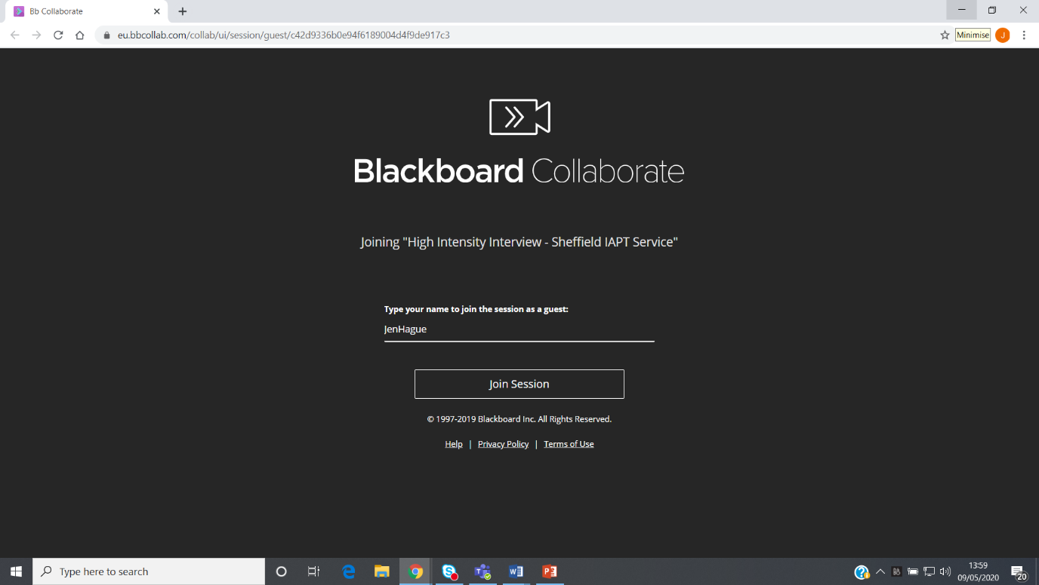

Please enter your full name as requested and then click ‘Join session’

Upon joining the session, you will see a virtual room like this:

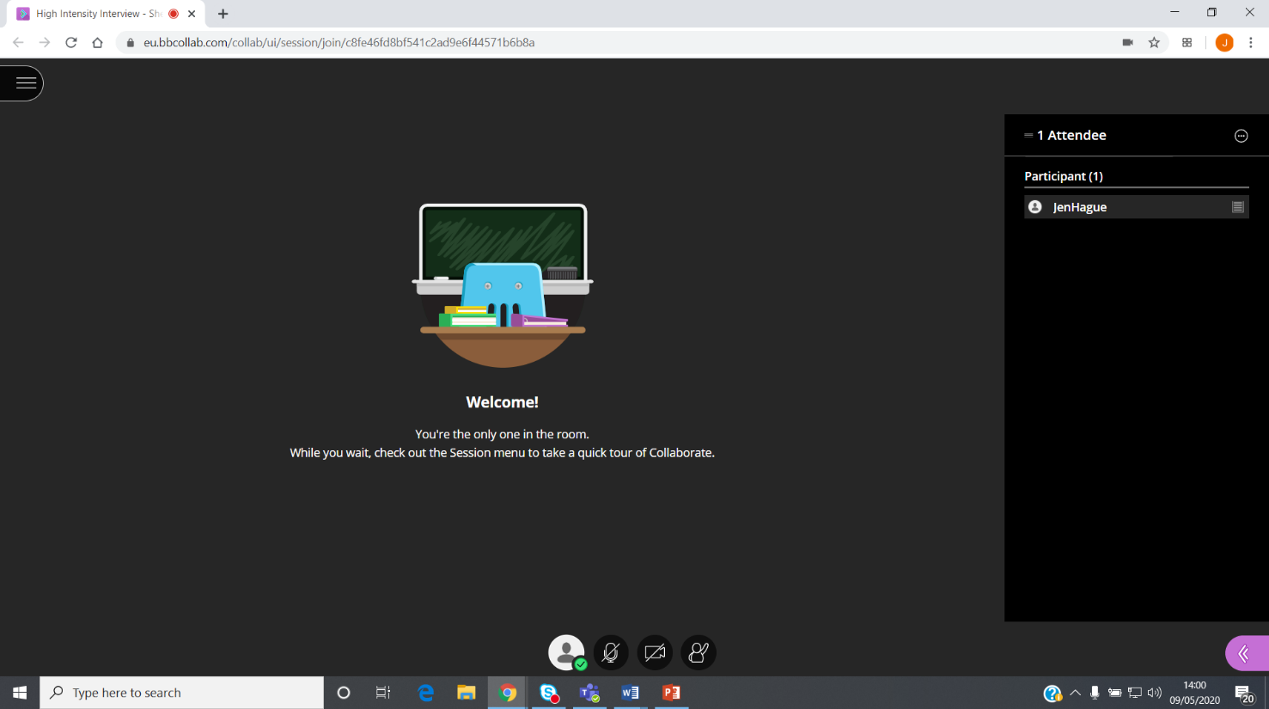

The panel members will be listed on the right. The button labelled A allows you to turn on your microphone. The button labelled B allows you to turn on your video. The button labelled C allows you to raise your hand- you will be unlikely to need this function.

By selecting to share video you will see the following screen. Please check your image is clear and then click share video: 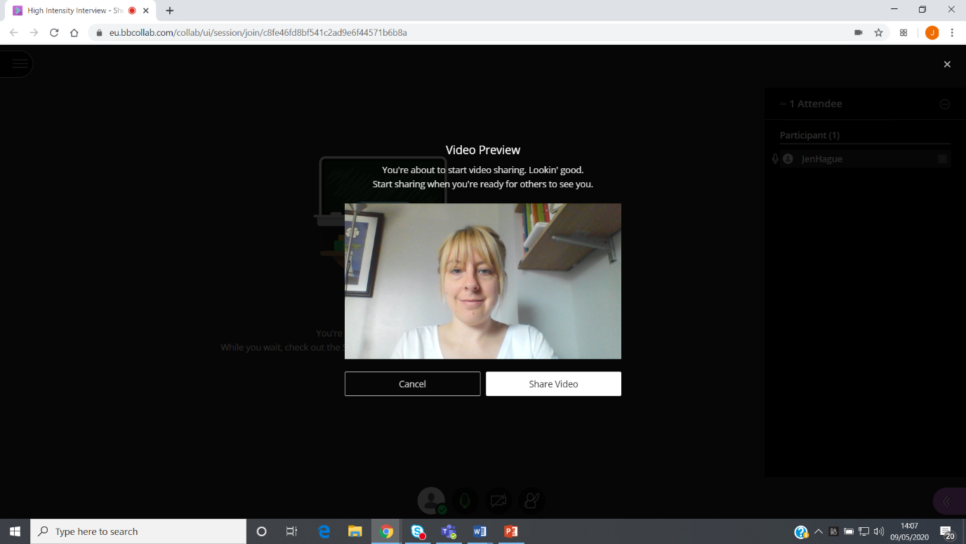

Your own image will appear very small in the bottom left-hand corner:

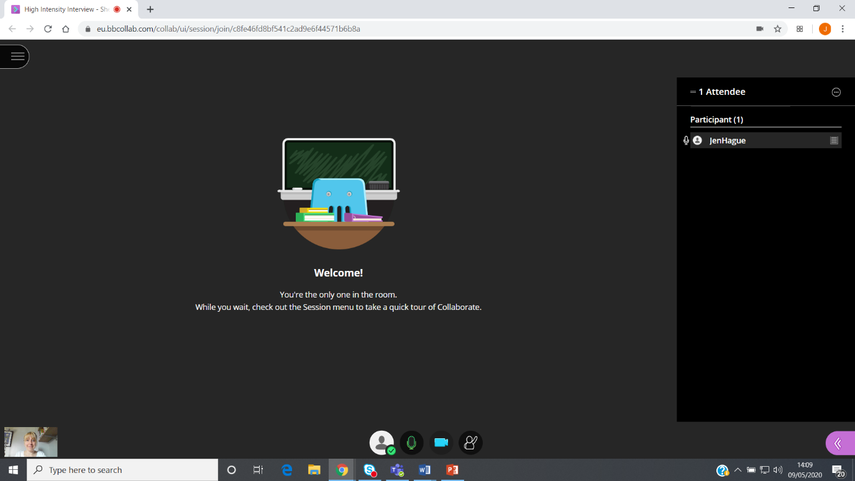

The panel members will be visible in the room.

At the end of the interview to leave the session you need to click on the 3 lines on 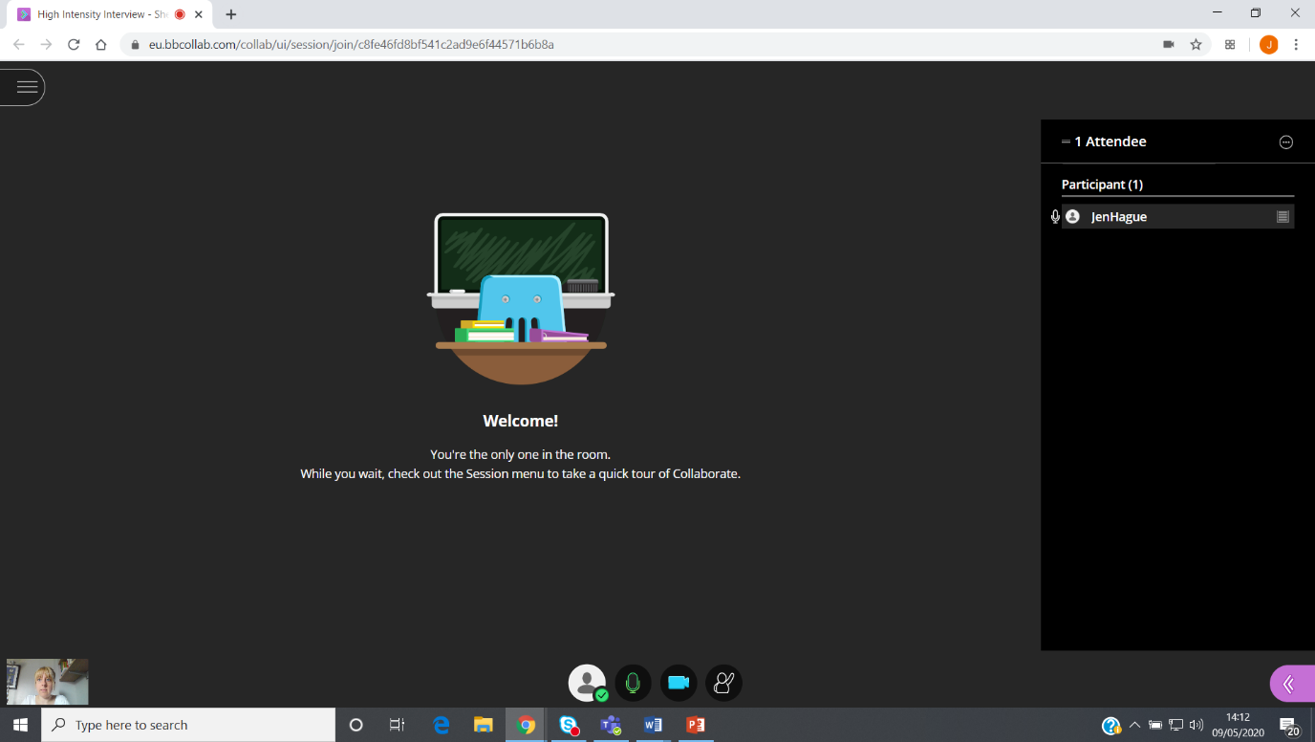the top left-hand corner



Click on leave session

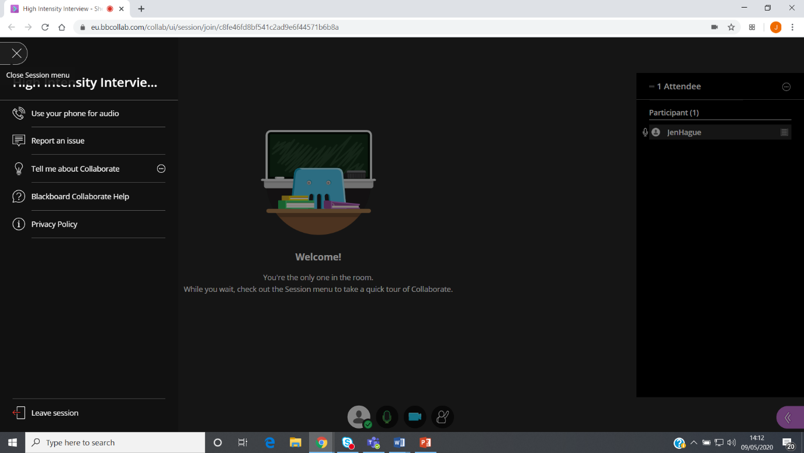

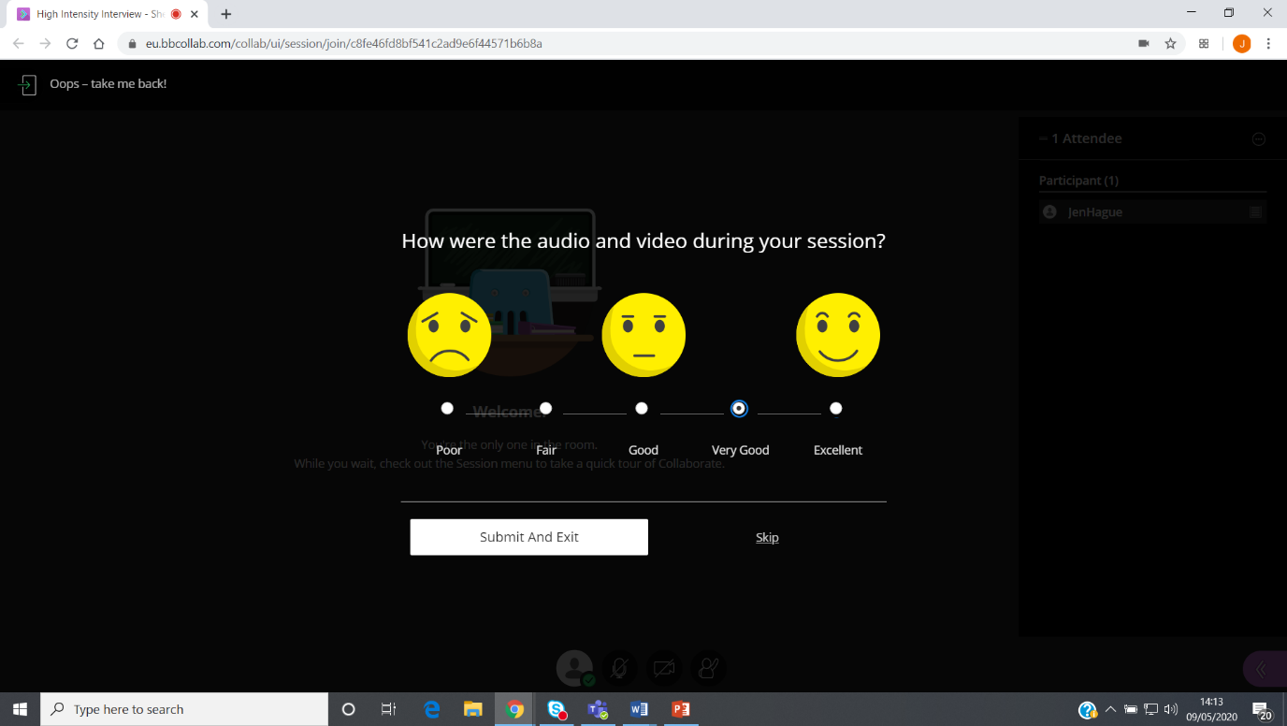

Rate the quality of the video call and then click ‘submit and exit’

When you see the screen below you have successfully left the room.

