Postgraduate Diploma in High Intensity Psychological Interventions (HIPI)

**HIPI Selection - Candidate Information Pack for Oct 2025:**

**HIPI Trainee applicants at the University of Sheffield**

**Interview process and guidance**

**REMOTE PROCESSES**

* The NHS TALKING THERAPIES service provider will send the link and details of the remote interview in the candidate invitation to interview email.
* The service provider may have asked the University to deliver the interviews via the University’s online teaching platform – Blackboard Collaborate. If so, please see below.
* A step by step guide to logging into Blackboard collaborate has been included below.
* A link to a test room on Blackboard Collaborate has been included for candidates to access prior to the interview to familiarise themselves with the system.
* The panel will usually be comprised of one university tutor and 2 service representatives.

**TECHNOLOGY**

Blackboard collaborate is an online learning environment used by the university for teaching, simulated clinical observations, interviews and tutorials. Access is enabled via a link sent from the NHS TALKING THERAPIES Admin team.

**Panel members and candidates will need to access via Google Chrome or Firefox to allow full video and audio functionality. You will require a strong wi-fi signal and fast internet connection. If the internet is not fast enough, the microphone and camera will not function. If your wi-fi is not fast enough, please connect to your router directly with an Ethernet cable.**

All candidates should access the test room prior to their interview to test their equipment. The link to this test room is here:

[**https://eu.bbcollab.com/guest/e185b4da759e40779049471c394e5898**](https://eu.bbcollab.com/guest/e185b4da759e40779049471c394e5898)

**NHS TALKING THERAPIES High Intensity CBT Trainee Recruitment Requirements**

**Candidate requirements**

* Candidates must have a first degree in an applied discipline (usually Psychology) in order to be considered.
* Candidates from a PWP background must have been qualified and practising as a PWP for **at least two years at the start date of the course** (from the date of the qualifying exam board) in order to meet national expectations.
* Candidates from a core profession background must have **at least two years post-qualification experience at the start date of the course**.
* Candidates are unable to progress through the recruitment process if they are already registered on a Health Education England (HEE) funded programme.
* Candidates must either meet one of the following BABCP core mental health profession requirements OR complete a KSA (see below):
  + Arts Therapists – HCPC Registered
  + Counselling – Accreditation with the BACP, IACP, COSCA, or FDAP (NCAC) -  Registration with these organisations isn't sufficient
  + Medicine – Psychiatrist or General Practitioner, MBChB or MBBS, and usually PG training with membership of MRCGP, MRCP or MRCPsych
  + Occupational Therapy – BSc (Hons) Occupational Therapy, MSc Occupational Therapy, or Dip C.O.T and HCPC Registered
  + Psychotherapy/ Psychotherapeutic Counselling - UKCP Registration
  + Registered Nurse – Mental Health (RMN), or Learning Disability (General Nursing and Enrolled Nursing is insufficient)
  + Social Work – CQSW, DipSW, MA Social Work, or BA/BSc Hons Social Work. Registered with one of four UK regulators - Social Work England (SWE), Social Care Wales (SCW), Northern Ireland Social CareCouncil (NISCC) and Scottish Social Services Council (SSSC)
  + Postgraduate Doctorate in Clinical/Counselling Psychology - accredited by the British Psychological Society and HCPC Registered as Practitioner Psychologist
  + Educational Psychology - Doctorate or QEPS - must have BPS Chartership (CPsychol) and HCPC Registration as Practitioner Psychologist
  + Health Psychology - QHP stage 2 - must have BPS Chartership (CPsychol) and HCPC Registration as Practitioner Psychologist
  + Forensic Psychology - QFP stage 2 - must have BPS Chartership (CPsychol) and HCPC Registration as Practitioner Psychologist

All candidates must provide the following information at interview:

* Evidence of a BABCP recognised core profession OR an electronic completed KSA portfolio.

**KSA portfolio**

Candidates who do not meet recognised core mental health profession requirements must submit a completed Knowledge, Skills and Attitudes (KSA) portfolio to [talkingtherapiesadmin@sheffield.ac.uk](mailto:iapt@sheffield.ac.uk)

If the candidate is successful at interview the training place will be ratified after the KSA has been assessed as being of a suitable standard by the University. Candidates should therefore expect that their KSA will be reviewed for assessment and the electronic document should include scanned copies of all evidence.

A KSA portfolio has a number of criteria which must all be met by every applicant. There are some professional backgrounds which mean that the applicant has already met a number of the criteria, and can therefore provide a condensed KSA. Other backgrounds mean that the applicant must complete all of the sections. Further details on the KSA, and what sections candidates must complete, can be found here:

<https://babcp.com/Accreditation/Provisional-Accreditation/Knowledge-Skills-and-Attitudes>

Please note:

* All KSA candidates should check the BABCP website to confirm which sections of the KSA portfolio they need to complete.
* KSA candidates must produce a statement for each of the relevant KSA criteria and list the supporting evidence that they have provided.
* Each statement is expected to include illustrative examples and sufficient depth of information to demonstrate how the candidate meets equivalence of core professional training in this area.
* In order to be accepted on the course the KSA (or condensed KSA where appropriate) needs to be fully completed to the required standard.
* For criteria that require a reference or a counter-signature, these **should** be included at this point
* Candidates will be eligible to apply for BABCP provisional practitioner accreditation 12 months after meeting the KSA requirements.
* Candidates whose KSA portfolio is not of the required standard will not be eligible to enrol on the training and will not receive feedback on their KSA.

Further details, including detailed guidance on completing the KSA, can be found here:

<https://www.sheffield.ac.uk/clinicalpsychology/programmes/iapt/ksa>

**Previous enrolment on a funded CBT training course**

Repetition of training is not supported if the candidate has completed a funded training programme and failed.

Candidates who have previously withdrawn from a funded course will be considered only upon receipt of an academic reference from the original University. This reference must indicate that the individual’s withdrawal was due to clear extenuating circumstances which would suggest that a repetition of training would be good use of public money.

Candidates who have previously withdrawn from a funded CBT course should bring the following information to the interview:

* Name of the institution attended
* Name of the course
* Departmental name/ contact number and email for the course

**Current enrolment on a HEI training course**

The University of Sheffield is unable to accept any candidates who are currently enrolled on any training course at any other HEI institution.

**Right to Work in the UK**

All candidates who hold a visa should ensure that their visa permits the right to work and study in the UK. As the course incorporates both work and study, it is the University’s understanding that both the Student visa and the Graduate Route visa prevent candidates from completing both elements of the course without breaching their visa conditions:

* The Student visa is bound by Student visa work conditions which would not allow the candidate to work in the full time permanent position required by the service.
* The Graduate Route visa does not permit the level of study associated with the course.

There may also be restrictions on other visa types. It is the responsibility of the candidate to ensure their visa permits both work and study to the degree required by the course. Any candidate who is successful in obtaining a place on the course, but does not hold an appropriate visa, will not be permitted to register on the course.

If a candidate is unsure as to whether their visa permits both work and study, they should obtain independent advice from an authorised immigration adviser or legal professional.

**Structure of interview for shortlisted candidates**

The interview will be conducted in three phases:

1. A role play to enable the candidate to demonstrate clinical skills with one of the panel playing the role of a depressed or anxious patient. The candidate will be required to reflect on their performance. The reflections will be expected to relate to the clinical skills not the method of delivery per see. The panel appreciate that remote delivery might be novel to the candidate and this will be taken into consideration within the interview.
2. A series of questions from the panel relating to the High Intensity trainee role about the candidate’s knowledge, skills and relevant experience.
3. An opportunity for the candidate to ask questions of the panel about the trainee role.

The interview will take no longer than 60 minutes.

**Further information about the role play practice demonstration**

* The candidate will be asked to interview a ‘patient’ who has been referred for assessment for High Intensity CBT.
* The demonstration will last for no more than 10 minutes. The candidate will be responsible for managing the time. A member of the panel will bring the demonstration to a close if the time has gone past 10 minutes.
* There should ideally be a beginning, middle and end structure to the demonstration. Furthermore, it is not expected that the candidate will showcase the first 10 minutes of a 50-minute session, nor does a 50-minute session have to be condensed into 10 minutes.
* The main goals of the session are to begin the process of developing a therapeutic alliance with the patient and to gather information about the patient’s difficulties. The candidate may help the patient to understand their problems from a CBT perspective, but this is nota requirement. It is not expected that the candidate will explain the process of CBT treatment.
* For the purpose of this time-limited demonstration the candidate will not be required to discuss confidentiality or do a risk assessment.
* This is an opportunity for the candidate to demonstrate some basic CBT skills. The person playing the role of the patient will not be difficult or unhelpfully complex. The patient will present with either Depression or one of the Anxiety disorders.
* If the candidate wishes to make notes or use a diagram in the role play, they will need access to a bold black felt tip pen and blank paper. This enables best visibility when shared across video link. This is not a requirement.

**Successful candidate requirements**

Successful candidates can expect their service to provide the following:

* All successful HIPI candidates are required to have a BABCP accredited practitioner as their clinical supervisor from the start of their training.
* Trainees must have the opportunity to observe qualified CBT therapists in practice as part of their training.
* Trainees must have access to suitable quality and quantity of Step 3 NHS TALKING THERAPIES training cases.
* Trainees must have access to audio visual recording equipment and appropriate means to upload the recordings to the University’s secure server.

Trainees must become members of the BABCP, and we advise this is done prior to or immediately when commencing the course. Membership numbers will be collected by the University at the start of the training.

Please note that trainees undertaking the course who require an interruption to studies due to unexpected extenuating circumstances will need to seek approval from NHS-E for a formal extension to studies. If granted, a maximum of an additional 12 months will be permitted for completion of the programme.

**Blackboard Collaborate User Guide**

The NHS TALKING THERAPIES service provider may ask The University of Sheffield to host the interview. If this is the case, the interview will take place on Blackboard collaborate. You will be sent a ‘guest link’ in your invitation to interview email, like the one below:

<https://eu.bbcollab.com/collab/ui/session/guest/e185b4da759e40779049471c394e5898>

You will need **Google Chrome or Firefox** to enable you to have full audio and video functionality during the interview.

The link will take you to the following page:

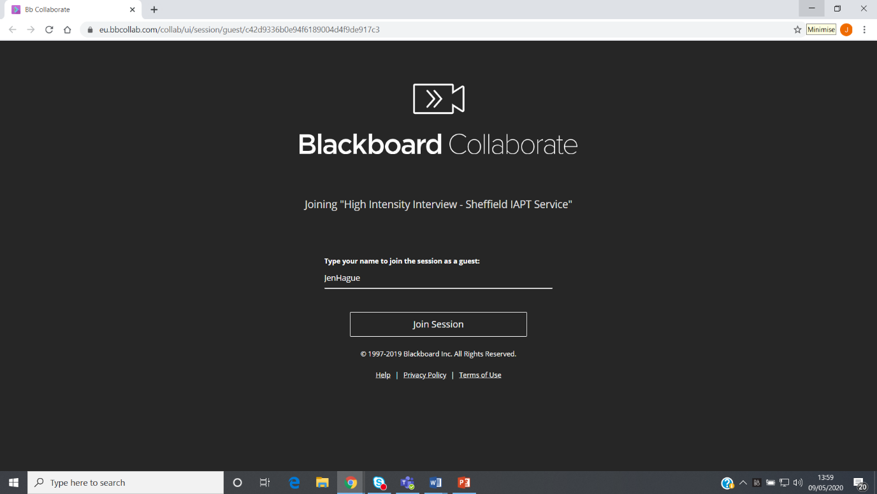

Please enter your full name as requested and then click ‘Join session’

Upon joining the session, you will see a virtual room like this:

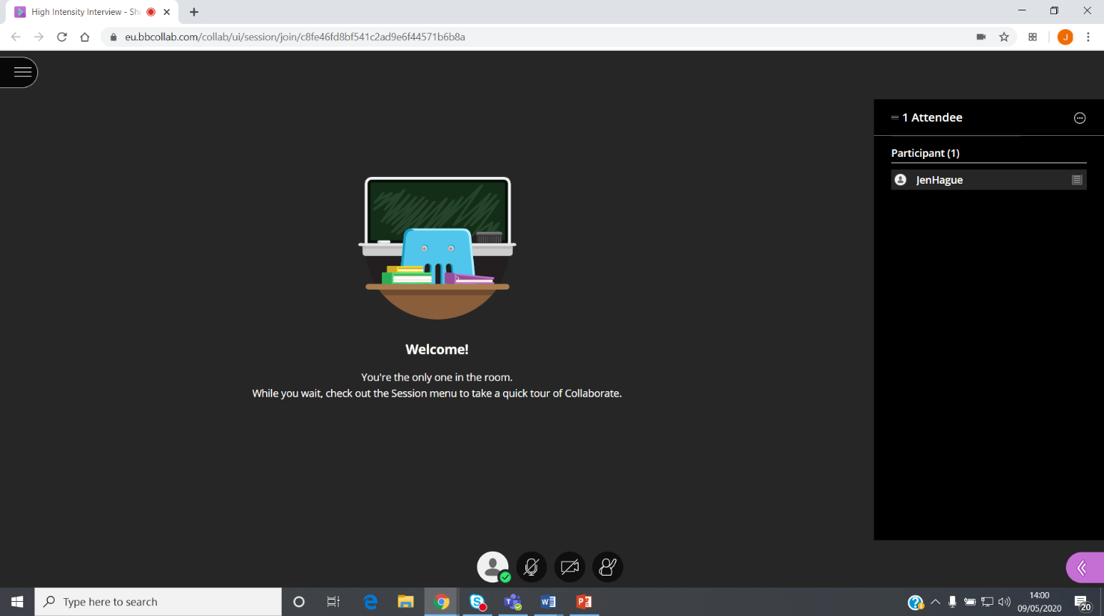

**C**

**B**

**A**

The panel members will be listed on the right. The button labelled A allows you to turn on your microphone. The button labelled B allows you to turn on your video. The button labelled C allows you to raise your hand- you will be unlikely to need this function.

By selecting to share video you will see the following screen. Please check your image is clear and then click share video: 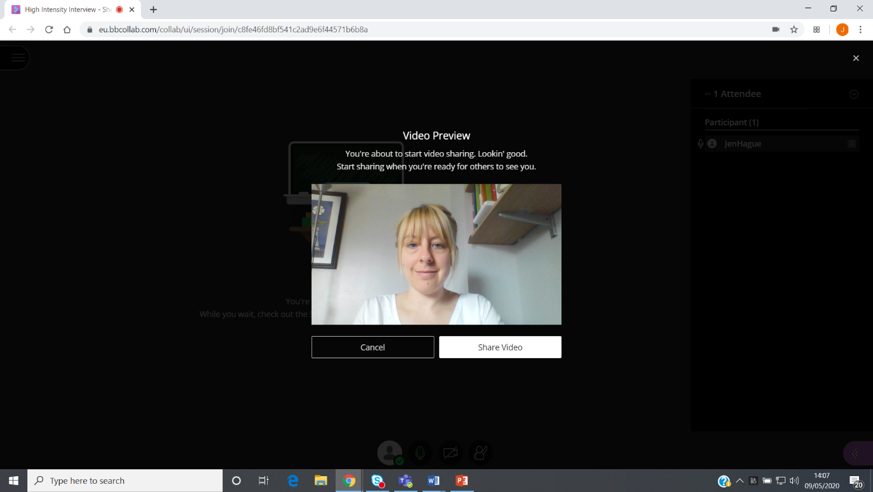

Your own image will appear very small in the bottom left hand corner:

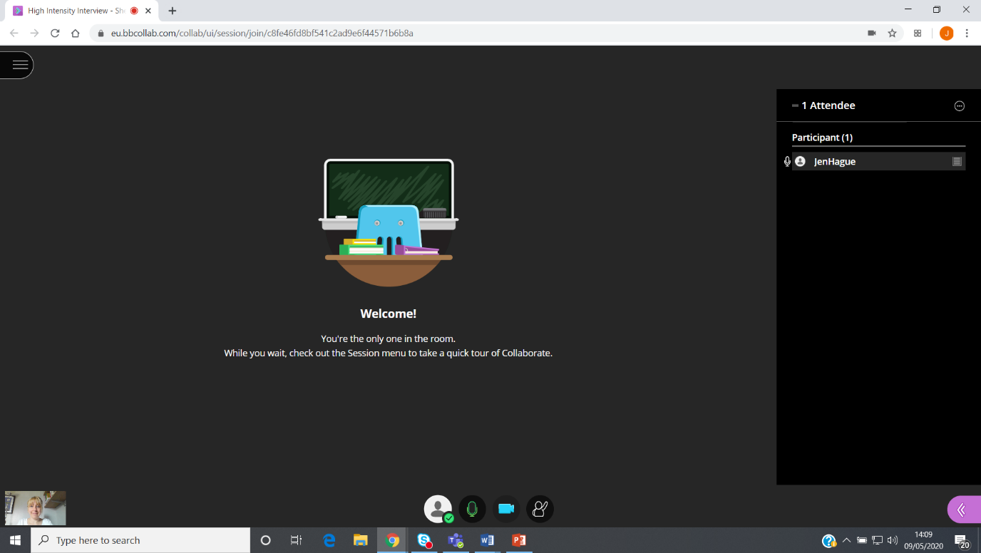

The panel members will be visible in the room.

At the end of the interview to leave the session you need to click on the 3 lines on the top left hand corner

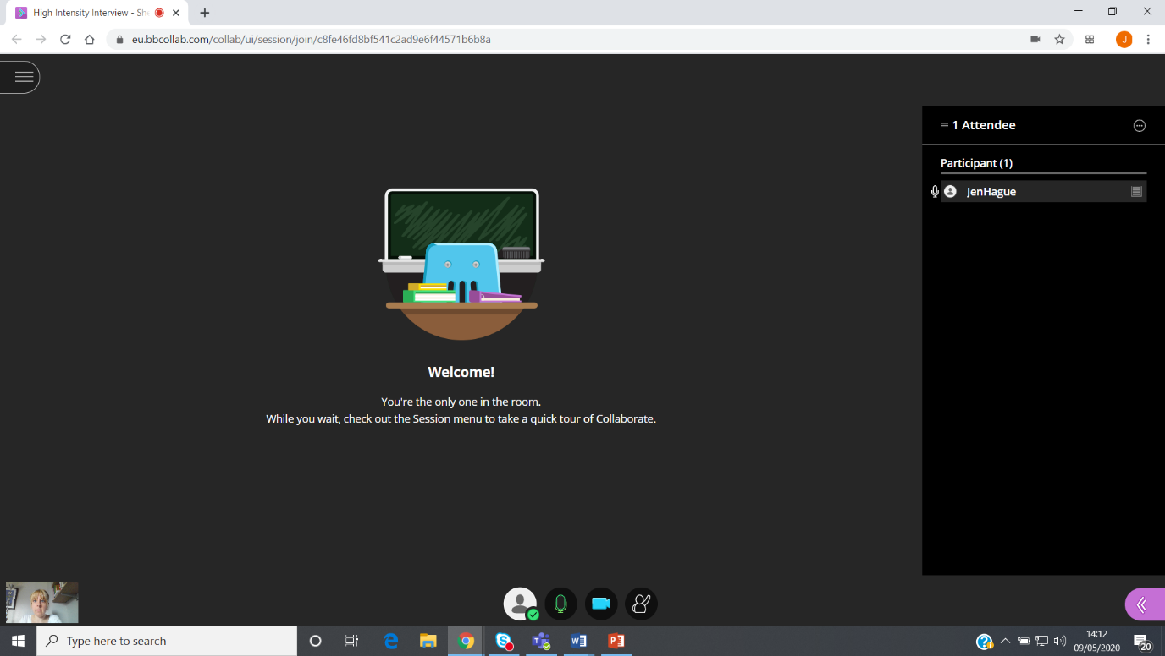

Click on leave session

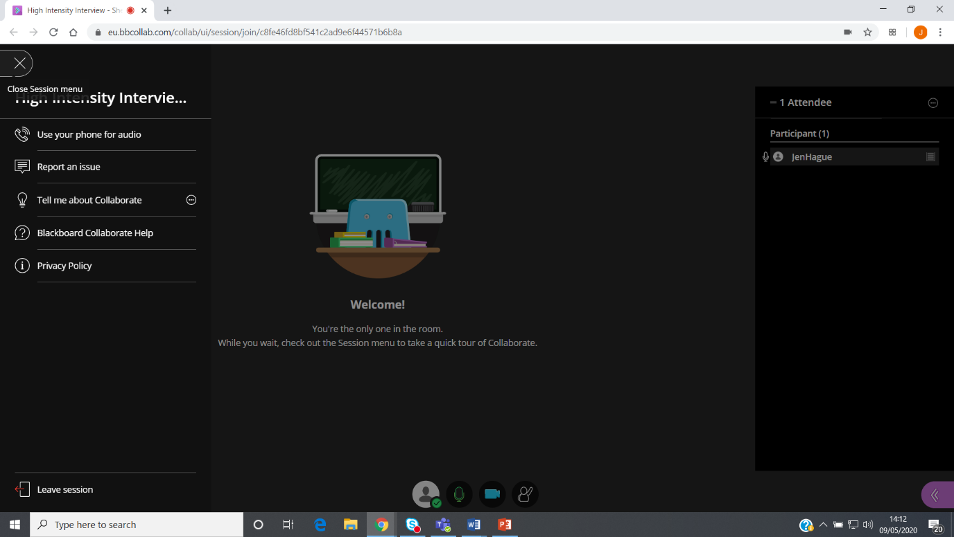

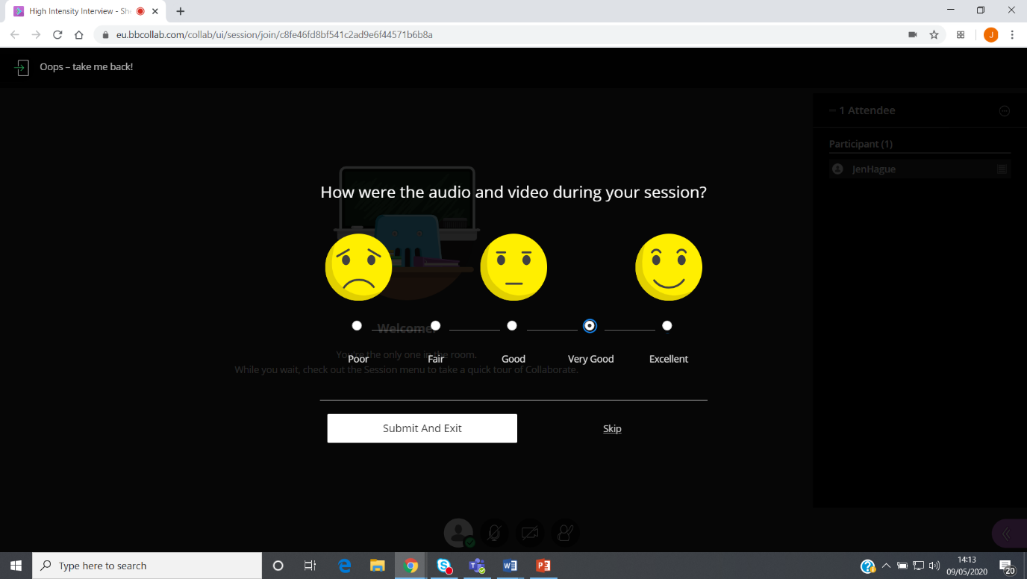

Rate the quality of the video call and then click ‘submit and exit’

When you see the screen below you have successfully left the room.

