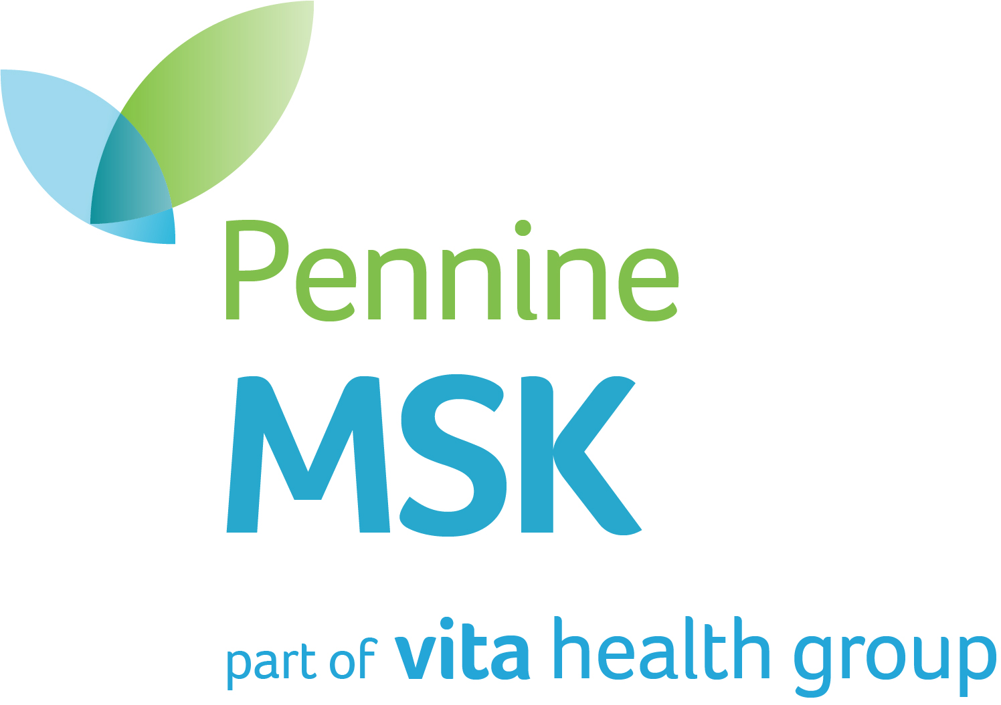

JOB DESCRIPTION

POST: Consultant Rheumatologist
NATURE OF APPOINTMENT: Permanent, NHS Consultant Terms and Conditions.
BASE: Pennine MSK Partnership, Integrated Care Centre, Oldham
NUMBER OF PAs: 6

RESPONSIBLE TO: Clinical Director and Senior Leadership Team (Pennine MSK)

JOB SUMMARY

A part time consultant rheumatologist is required to join the existing team working at Pennine MSK, an innovative and award-winning community based MSK service providing integrated rheumatology, MSK and pain service provision to the people of Oldham. Pennine MSK is part of part of VITA Healthcare which is itself part of Spire Health. This appointment [6PAs] will be made in accordance with the 2003 Consultant Contract Terms and Conditions.

The Job Description indicates the main duties of the post, which may be reviewed in the light of experience and developments within the service. Any review will be undertaken in conjunction with the post holder.

ABOUT THE POST

1. Pennine MSK

An opportunity has arisen for a consultant to join our busy and dynamic rheumatology Team.

Pennine MSK (PMSK) provides rheumatological care for the people of Oldham, a population of approximately 230,000. We are an innovative community-based organisation that provides comprehensive care of patients with musculoskeletal problems. In addition to rheumatology, the service also provides specialised physiotherapy assessment, podiatry, occupational therapy, elective orthopaedics, fracture liaison and persistent pain services. The rheumatology service is based at the Integrated Care Centre (ICC), a well-equipped, modern community facility in the centre of Oldham. The post holder’s role would be to support and complement the work of the existing rheumatology consultants and a number of specialist rheumatology nurses as well as supervision of both GP and higher specialist trainees. You will work closely with the multidisciplinary team which includes GPs with special interests in musculoskeletal medicine and sports and exercise medicine

PMSK was acquired by VITA Healthcare in April 2022 and since October 2023 we have been part of Spire Healthcare group which affords wider career development opportunities.

PMSK would welcome applications from general rheumatologists with a specialist interest.

2. Pennine MSK: Key relationships and Ethos

Rheumatology MDT:
Robert Ley | Consultant Rheumatologist, Medical Director
Vinodh Devakumar | Consultant Rheumatology and GIM, GIM Training Programme Director – HEENW
James Bluett | Consultant Rheumatologist and Senior Lecturer (joint appointment with University of Manchester)
Imna Rahiman | Consultant Rheumatologist
Danielle Whitmore | Lead Specialist Nurse
Harpreet Kaur | Rheumatology Specialist Nurse
Andrea Stoker | Rheumatology Specialist Nurse
Nicola Collins | Rheumatology Specialist Nurse
Meranda Henri | Rheumatology Specialist Nurse
Sarah Critchley | Rheumatology Specialist Nurse and Lead Director
Andrew Swan | Lead Rheumatology Physiotherapist
Charlotte Critchley | Rheumatology OT
Emma Hughes | Specialist Rheumatology Pharmacist
Helen Light | FLS Specialist Nurse
Anita Ho | FLS Pharmacist
Other specialist nurses, extended scope physiotherapists, podiatrists and GPwSIs provide support on a sessional basis

PMSK is an independent provider of NHS care, commissioned by Greater Manchester ICB to provide comprehensive specialist care in musculoskeletal disorders and persistent pain. The ethos of PMSK conforms to the “Triple Aim” framework developed by the Institute for Healthcare Improvement: to improve the health of the population, to optimise patient experience and to do this at the best possible value. We see the person with musculoskeletal problems as being at the heart of the service and have been proactive in developing systems for shared decision making and supporting self-management along with social prescribing. We believe that we should use the full potential of all our clinicians and have a strong multi-disciplinary ethos. Our achievements have been recognised at national level with two Best Practice awards from the British Society for Rheumatology and the Nursing Standard, and the rheumatology service has achieved outcomes among the top 5% in England and Wales in the National Early Arthritis Audit. We have been awarded the customer service excellence award for 10 years in a row.

We provide a comprehensive range of rheumatology outpatient services and procedures and have our own infusion suite.

Our waiting times for appointments are short, and most patients (new and follow up) can be seen within a few weeks.

In practical terms, PMSK aims to be rapidly responsive to the needs of our patients and to provide care that is consistent, and evidence based. Our specialist nurses take a central role in delivery of rheumatology services and lead the majority of out-patient follow up work. Medical expertise is used where it is felt to be most helpful, usually troubleshooting when patients are facing treatment failure, diagnostic uncertainty or issues with co-morbidities, and providing a rapid clinical opinion in these situations.

We maintain close relationships with the Royal Oldham Hospital (about 0.75 miles from the ICC), part of Northern Care Alliance Hospital Group. Acutely ill patients with rheumatological illnesses are admitted, usually under the care of Dr Devakumar who provides a ward referral service to the hospital site. We have good working relationships with allied specialties: all major medical and surgical specialties are represented within the trust apart from Neurology, Nephrology and Dermatology which are provided by visiting consultants from Salford Royal Foundation Trust. There are also close relationships with the Liaison Psychiatry and Psychological Therapy services provided by Pennine Care Foundation Trust as these form an integral part of the local persistent pain service.
The organisation is continually evolving and developing with an on-going commitment to service development. Development of our Giant Cell Arteritis is an example of a current priority.

This is a new post to with the key drivers for its development the planned, controlled expansion of our patient population through referrals being opened to localities surrounding Oldham as part of the PMSKs growth plans alongside a colleague obtaining a NIHR National Clinical Lead Role necessitating a reduction in their clinical sessions at Pennine MSK.

We have good link with the University of Manchester and other rheumatology centres across the North West as well as with primary care colleagues and the ICB. There is a monthly regional rheumatology education meeting, at the University of Manchester, into which our rheumatology team have an active contribution and a twice-yearly North-West Rheumatology Club meeting covering the North West and Mersey regions.

The ratio of new to follow up appointments is flexed according to the needs of the service but on average the new: follow up ratio is around 1:6 in Rheumatology.

3. Facilities

Clinical aspects of the rheumatology service are delivered from dedicated modern outpatient facilities on the second floor of the Integrated Care Centre, New Radcliffe Street, Oldham (ICC), and there is also a day-case unit for infusions, minor surgery and other treatments.

Essential laboratory facilities are located at the Royal Oldham Hospital and PMSK have phlebotomy services supporting all clinics, with regular transport of samples from the ICC. Plain X-rays are performed at the ICC, and cross-sectional imaging on the hospital site. The PMSK rheumatology service has its own ultrasound machine, and USS clinics are also delivered by a visiting sonographer as well and two members of the rheumatology MDT who are trained in MSK USS.

PMSK has dedicated office space on the 6th floor of the ICC. This is an open plan office where the appointee will have a personal PC with intranet and internet access. Rooms are available for private meetings.

PMSK utilizes SystmOne as the electronic medical record system and does not utilize paper based medical records. SystmOne is available on the PCs in all the clinic rooms at the ICC.

The appointee will have secretarial support from a team of Rheumatology secretaries.

4. Teaching and Training

PMSP is committed to supporting the requirements for ‘Continuing Medical Education’ as laid down by the Royal College of Physicians and is committed to providing time and financial support for these activities.

The post holder will be expected to actively contribute to postgraduate and multi-disciplinary teaching.

PMSK hosts Specialty Trainees in Rheumatology, Sports and Exercise Medicine and General Practice and it is anticipated that the appointee would act as Clinical Supervisor to at least one of these trainees once appropriately trained. Appropriate time would be dedicated to this in the Job Plan.
5. Leadership Team

PMSKP is led by a Senior Leadership Team: a simple, single tier, management structure which allows for rapid and responsive decision making.

Senior Leadership Team

Sarah Critchley | Lead Director and Rheumatology Specialist Nurse
Dr Robert Ley | Medical Director, Responsible Officer and Consultant Rheumatologist
Dr Shelley Grumbridge | Director & GPwSI Pennine MSK Partnership  Deputy Associate Medical Director GM ICS Oldham Locality
Emma Hughes | Clinical Governance Lead and Specialist Pharmacist Rheumatology
Andrew Swan | MSK services Lead and Extended Scope Physiotherapist
Kathy Kinsey | Service Improvement Lead
Dr Hollie Francis | Pain Service Clinical Lead

6. Job Plan - Rheumatology

Direct Clinical Care 4 Programmed activities
Supporting professional activities 2 Programmed activities

An individual job plans will be discussed with the post holder on appointment and will undergo review between the appointee and the Clinical Director, within six months of the commencement date of the appointee. The exact timetable will be flexible and will incorporate lunch breaks, arranged in discussion with the appointee ensuring that it meets the requirements of the Consultant contract and service needs of PMSK. This will be approved by the Clinical Director and the Senior Leadership Team.

The Job Plan will be reviewed at least annually, following a job planning meeting. The Job Plan will be a prospective agreement that sets out a consultant’s typical working pattern, duties and responsibilities and objectives for the coming year. It will cover all aspects of a consultant’s professional practice including clinical work, teaching, research, educational and managerial responsibilities and any external commitments. The successful candidate will be expected to organise their own workload.

There is no on-call commitment is part of the standard job plan.

1 PA Core SPA will be allocated for professional development (CPD), job planning, appraisal, mandatory training, attendance at team meetings including governance and audit. Core SPA will usually be undertaken at PMSK.

Additional SPA time will be made available based on evidenced need. Such allocation will be agreed and thereafter reviewed by the consultant and clinical director during job planning review.

Clinic templates will be set at 6 new or 12 follow up slots (or equivalent e.g. 3 new and 6 follow up) with a slot left empty to allow appropriate regard to clinical supervision when trainees are in attendance.

Rheumatology receives ward referrals from between none up to six per week. These referrals are usually attended during the rheumatology/GIM Consultant’s work at The Royal Oldham Hospital, during the time allocated to reviewing outliers. When these referrals are received when the Rheumatology/GIM consultant is absent there will be an expectation that responsibility for review of the in-patients will be shared between the rheumatology team members.

While there will be flexibility around days of work, an example of the indicative job plan is shown below.

 | Monday | Tuesday | Wednesday | Thursday | Friday
AM |  | Rheumatology OPD clinic  (1PA DCC) | Rheumatology OPD clinic  (1PA DCC) | Rheumatology OPD clinic  (1PA DCC)
Lunchtime
PM |  | Service development work, research, and support for educational role  (1PA SPA) | CPD, Audit, Governance, and mandatory training  (1 Core SPA) | PMSKP MDT support, clinical admin,  (1PA DCC)

The job plan incorporates dedicated time for clinical audit and audit is a requirement of all clinical staff at PMSK.

PMSK has the required arrangements in place, as laid down by the General Medical Council regulations, to ensure that all doctors have an annual appraisal with a trained appraiser and supports doctors going through the revalidation process. Appraisal is currently undertaken by trained appraisers based at the Northern Care Alliance NHS Foundation Trust. The post holder will be required to engage with all the requirements for revalidation. The PMSK Responsible Officer provides assurance of compliance annually to the senior leadership team.

Development opportunities will be available for a new consultant to aid transition into their role with leadership development, networking, education, and mentoring. Mentoring support for the new post holder will be provided by Dr Ley.

7. Principle duties of the Post

The principle duty of the post is to provide a comprehensive clinical service to the patients of Oldham and including clinical, administrative, supervisory, educational, and training support for the day to day running of the rheumatology service.

Active involvement in the future developments of the service will be essential.

The tasks and duties outlined below are not definitive but cover the main duties of the post and may be changed in accordance with the needs of the service.

Duties include:
- To, at all times, comply with the GMC requirements of Duties of a Doctor
- To ensure that appropriate patient confidentiality is maintained at all times
- To undertake the duties as defined within the job plan in so far as is practicable and in agreement with your clinical lead and the Senior Leadership Team, as reviewed annually
- To be responsible and managerially accountable for the effective use of resource that you use and have influence over, and be professionally accountable to the organisation medical director
- To participate in the mandatory training programme and maintain CME/CPD requirements as laid down by the Royal College of Physicians
- To be responsible for the clinical management of patients under your charge including all administrative duties associated with patient care
- Development of existing clinical protocols and pathways to maximise efficiency and effectiveness of the service
- To provide support and clinical supervision to other members of the rheumatology MDT and wider service as appropriate
- Contributing to training and development opportunities for medical, nursing, therapy and other allied staff associated with Pennine MSK
- Demonstrate commitment to and participation in clinical governance, audit and risk management. Pennine MSK has been proactive in regional and national audits in rheumatology, and it is anticipated that the post holder will support the further development of clinical audit.
- Conducting appropriate duties in cases of emergencies and unforeseen circumstances.
- Professional supervision and management of junior staff. This includes supervising juniors, nurses, and students when clinic templates are amended accordingly to incorporate clinic catch up slots to allow time for supervision.
- Responsibility for carrying out teaching, examination and accreditation duties as required and for contributing to postgraduate and continuing medical education activity, locally and nationally.
- Collaboration with colleagues in primary and secondary care to implement protocols for the enhanced management of patients
- Keep up to date with developments within rheumatology
- There is the opportunity to perform clinical research and development and to build on the current rheumatology research profile in PMSK

8. Research and Development

Research is a core part of PMSKP business. There is an expectation to deliver evidence-based care and contribute to the evidence base through support of research studies. This includes NIHR portfolio studies. The post holder will be encouraged to undertake appropriate research with the opportunity to develop in house studies.

Dr Bluett is the research lead and is supported by two research nurses.

It is the post-holder’s duty to ensure that all research conducted within PMSK is in accordance with the NHS Research Governance Framework for Health and Social Care.

9. Visiting

Prospective candidates are encouraged to visit Pennine MSK Partnership and meet members of the management team and other senior members of staff. Appointments can be made for a visit at any point prior to the date of interview.

10. Additional Requirements

The post is subject to NHS pre-employment checks. Accordingly, all postholders must have satisfactory Occupational Heath and DBS (enhanced level) clearances. At the interview stage, the postholder will have provided evidence of their identity, right to work in the UK, qualifications and professional registration and the recruitment team will have verified their suitability for the post through reference checks.

11. Further Information

For further information regarding the post and/or the Trust, please contact: Dr Robert Ley (Consultant Rheumatologist and Medical Director, robert.ley@nhs.net) or Sarah Critchley (Lead Director, sarahcritchley@nhs.net).

PENNINE MSK PARTNERSHIP
PERSON SPECIFICATION

Post: Consultant Rheumatologist

Attributes | Essential | Desirable | Assessment  method
Qualifications& Conditions | - Full registration with the General Medical Council with a valid licence to practice (or demonstrates eligibility to apply for registration and license)  - MRCP UK or Ireland  - MRCP Rheumatology  - Inclusion on the Specialist Register or a Specialist Registrar within 6 months of the award of their CCT (or recognised equivalent if outside the UK) at the date of interview | - Post Graduate Degree e.g. MD, PhD, MSc | A  A  A
Experience, knowledge and skills | - Wide experience in Rheumatology  - Ability to demonstrate clinical experience and skill in all aspects of rheumatology and in related practical procedures  - Knowledge of Good Medical Practice and the General Medical Council requirements.  - Good understanding of Clinical Governance | - Publication of research articles, demonstrating understanding of research methodology and commitments | A/I/P  A/I/P  I  I/P
Teamwork | - Works effectively with medical colleagues and whole MDT towards shared goals.  - Proven ability to build and maintain effective teams  - Positive attitude towards a nursing and support team led services  - Willingness to work with colleagues and leadership team to maintain and develop a comprehensive service |  | I
Leadership | - Is able and willing to take on leadership role  - Enquiring and critical approach to work  - Strategic thinker  - Capable of building trust and confidence |  | A/I
Communication | - Excellent verbal and written communication skills  - Demonstrates empathy and sensitivity to patients’ needs  - Excellent interpersonal skills and the ability to deal with difficult situations |  | A/I  I
Management | - Evidence of development and management of change  - Ability to manage risk and end of line decisions.  - Ability to cope with change  - An understanding of management in the context of the Health Service. | - Able to manage and lead change internally and within multi-agency setting  - Satisfactory completion of a management course | A/I  I  I
Teaching | - Experience of teaching juniors, medical students and other health care professionals.  - Ability to teach clinical skills  - Experience of supervision of postgraduate trainees | - GMC Registered Clinical and Education supervisor | A/I
Audit & Research | - Evidence of audit work and quality improvement activity and where this has brought about change  - Evidence of participation in research | - Evidence of work submitted for Peer review | A/I  A/I
Work ethic | - Works diligently and effectively to deliver a high-quality service  - Adheres to high ethical standards  - Takes responsibility for delivering results  - Personal time management skills |  | A/I
Other | - Residing or prepared to reside within reasonable access to the place of work  - Satisfactory Work Health Assessment |  | I  O

Key – A - Application Form, I - Interview, P - Presentation
O Medical screening.

It is important for candidates to show in their application forms how they meet the stipulated requirements.

